Financial Health and Sustainability Framework
Core Question: Is the charter school financially viable?

Revised March 2023
The Annual Report Toolkit is a product of CA 2.0—Advancing Equity and Access through Quality Authorizing—an initiative led by the California Charter Authorizing Professionals (CCAP).

Contents
Contents i
FINANCIAL HEALTH AND SUSTAINABILITY FRAMEWORK 1
Introduction 1
Framework Structure 2
Terminology Overview 3
Short-Term 3
Sustainability 3
Financial Performance Framework Detail 4
Short-Term Indicators 4
Sustainability Standards 12
Fiscal Controls 15
FINANCIAL HEALTH AND SUSTAINABILITY: TEMPLATE 18
Short-Term Indicators 18
Sustainability Standards 22
Fiscal Controls 24

FINANCIAL HEALTH AND SUSTAINABILITY FRAMEWORK

Core Question: Is the charter school financially viable?

Introduction
One of the primary responsibilities of an authorizer is to “monitor the fiscal condition of each charter school under its authority.” Education Code Section 47604.32. The California Education Code does not define the fiscal condition of a charter school or say how an authorizer should monitor it — this is left to the authorizer and the charter school operators and should be articulated in the approved charter petition and the memorandum of understanding (MOU), between the authorizer and the school, if applicable. According to the California Fiscal Crisis and Management Assistance Team (FCMAT), “fiscal condition” refers to all things financial, including budget, cash flow, and financial reporting.
This Financial Health and Sustainability Framework (Framework) is intended as a starting point for authorizers to adapt so that they can evaluate their authorized charter schools’ fiscal condition and performance as part of ongoing adequate and appropriate oversight. The Framework provides authorizers with a tool to identify schools that are in a healthy fiscal position and those that are currently in, or trending toward, fiscal distress. The Framework also supports authorizers to proactively evaluate and provide guidance to address any problems they identify using the Template that is provided with this tool.
Pursuant to Education Code Section 42100(b), charter schools must report their unaudited financial data to the California Department of Education (CDE). Guidance for reporting the data is presented in Procedure 810 of CDE’s California School Accounting Manual (CSAM) for use by the staff member(s) of the authorizing agency, or the charter school operator, assigned to record all accounting transactions and to prepare the required periodic financial statements.
This Framework relies upon a school’s reported financial data provided in the Adopted and Interim financial statements as the primary data source that the authorizer will use to determine short- and long-term fiscal health throughout the fiscal year. The budget presentation should include a multi-year financial projection (MYFP) and a cash flow that includes revenues, expenditures, and balance sheet items for 12-24 months for the authorizer’s use with several of the tools presented herein. At year end, authorizers should use the Unaudited Actuals Report for financial data, prepared by September 15th, due to the timeframe when audited financial statements are completed. Once the audit is complete, the authorizer should review for any audit adjustments, findings, and recommendations.
This Framework assumes that the majority of the financial data collection and reporting, presented in the Financial Performance Framework Detailed Examples section, is the responsibility of the authorizer. Authorizers are encouraged to triangulate charter school provided financial information with information collected during site visitations as well as third-party information from external sources such as bank statements, grant award letters and more.
This Framework is based on the collective work of the California Charter Authorizing Professionals (CCAP) and the Tri-State Alliance for the improvement of District-Led Authorizing, a collaboration among CCAP and its counterpart organizations in Colorado and Florida. The first iteration of the Framework, most of which was consistent with this revision, was prepared by WestEd and released by CCAP in April of 2021. Experienced guidance was further drawn from the National Association of Charter School Authorizers, FCMAT, CCAP and sample documents contributed by California charter school authorizers.

Framework Structure
The Framework is structured to gauge both short-term financial health and longer-term financial sustainability of charter schools and is organized around varied data, criteria, and standards and presented as indicators, measures, and metrics.
The standards reflect a general consensus among California School Business fiscal professionals and authorizers that implement accepted best practices codified in AB 1200, which establishes oversight requirements as to school district boards and county offices of education. The intent of providing the standards within this Framework is for the authorizer’s use as a basic oversight tool; however, each authorizer should review and add to or modify each review standard as it deems appropriate, especially during times of fiscal uncertainty or distress. Authorizers are encouraged to use the Template annually and with each financial reporting period.
Each standard on the Template includes a section where additional comments for context and details for required action may be completed by the authorizer and charter school operators. This section is particularly important when a reviewed item does not meet or falls far below the standard and a deeper review is necessary to discern if a reasonable set of circumstances surrounding the target exists to justify not meeting that standard.

Terminology Overview
The Framework includes two time periods used to evaluate a school’s fiscal condition: Short-term and Sustainability. The Fiscal Controls review items relate to the internal controls and audit of the charter school.

Short-Term
This section of the Framework is designed to assess a school’s short-term financial position and viability in the current fiscal year. Schools meeting the standards demonstrate a low risk of fiscal distress in the foreseeable future. Schools that fail to meet the standards may currently be experiencing fiscal distress and are at higher risk for fiscal insolvency.
It is important to note that authorizers should consider multiple indicators and metrics in conjunction with an overall assessment of fiscal health. Failure to meet individual measures should prompt additional review and request for information.

Sustainability
The Framework also includes longer-term sustainability standards. This section is designed to assess a school’s financial position and viability over the longer period beyond the current fiscal year focusing on the two subsequent fiscal years. Often this is referred to as the multi-year financial projection. Schools meeting the standards demonstrate a low risk of financial distress using multi-year trends and projections. Schools that fail to meet the standards may currently be experiencing fiscal distress or are projected to be at risk for fiscal insolvency in the future. This analysis can provide valuable information for the charter school to make the necessary budgetary adjustments in a timely manner.
The Education Code requires schools to submit financial information for the authorizer’s review and assessment of the fiscal condition of its charter schools. In accordance with Education Code Section 47604.33, each charter school is required to annually prepare and submit to its authorizer the following:
- On or before July 1, a preliminary budget. For a charter school in its first year of operation, the information submitted pursuant to subdivision (h) of Education Code Section 47605 satisfies this requirement.
- On or before July 1, a Local Control and Accountability Plan (LCAP) and an annual update to the LCAP required pursuant to Education Code Section 47606.5.
- On or before December 15, an interim financial report. This “first interim” report shall reflect changes through October 31.
- On or before March 15, a second interim financial report. This second interim report shall reflect changes through January 31.
- On or before September 15, a final unaudited report for the full prior fiscal year.
In addition to these requirements, the charter school is required to submit an audit of the financial statement no later than December 15th.
Although charter school operators are not required to provide positive, qualified or negative certifications of their schools’ ability to meet current and subsequent year financial obligations with their interim reports, the approved charter MOU may require this as a best practice. The three certification options are:
- A positive certification is given when the charter school will meet its financial obligations for the current and two subsequent fiscal years.
- A qualified certification is given when the charter school may not meet its financial obligations for the current or two subsequent fiscal years.
- A negative certification is given when a charter school will be unable to meet its financial obligations for the remainder of the current fiscal year or for the subsequent fiscal year.
For those authorizers without a certification reporting requirement, the Framework provides the following standards as a tool to assist with the authorizer’s periodic review.

Financial Performance Framework Detail

Short-Term Indicators

1. Days of Cash on Hand — “How many days of cash on hand does the school have to pay its bills?”
“Cash is King!” means cash is more valuable than any other asset, particularly when the majority of school operating expenses are for payroll and benefits. The definition of insolvency is when the charter school runs out of cash.
FCMAT’s Charter School Accounting and Best Practices Manual recommends a 5% cash reserve of the total of all budgeted expenditures to manage cash flow and avoid costly borrowing options. In addition to a cash reserve, days of cash-on-hand can be “at this point in time” which can be problematic given the timing of expenditures such as monthly payroll, rent and other large expenses.
The days of cash on hand ratio indicates the total number of days a school can pay its expenses without an influx of cash. This ratio tells authorizers whether the school has sufficient cash to meet its cash obligations without incurring a loan, or in some cases defaulting on a payment.
Should the State experience fiscal distress, as it did during the Great Recession, and initiate cash deferrals, the authorizer is encouraged to reevaluate the number of days to meet the standard depending on the deferral schedule.
Data sources: Balance sheet, Income Statement, and Bank Statements.
Note: If cash is restricted due to legal or donor requirements, or for other reasons, the restricted cash portion should not be included in the formula below.
Formula:
$$Days of Cash on Hand= \frac{Cash Received}{Budgeted Expenses/365}$$
Standard:
MEETS STANDARD: At least 60 Days of Cash on Hand
DOES NOT MEET STANDARD: 30-Less than 60 Days of Cash on Hand
FALLS FAR BELOW STANDARD: Less than 30 Days of Cash on Hand
Note: This is the only indicator in the Framework that includes a third option, for “Falls Far Below Standards.”
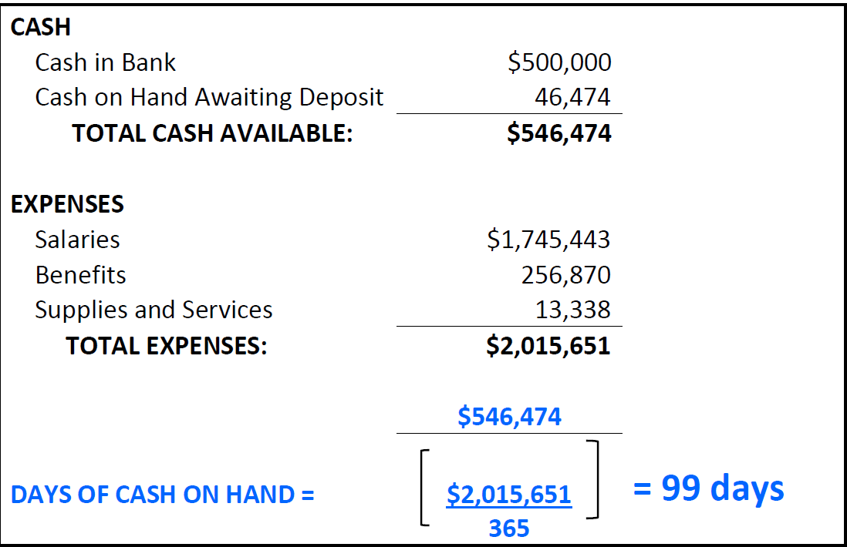
Example:
Conclusion: Meets Standard - Cash on hand exceeds 60 days.

2. Cash Flow Projection —“Will cash received meet obligations each month of the budgeted fiscal year?”

The Local Control Funding Formula (LCFF) is the calculation that supports most of the annual revenue available to the charter school. The calculation includes state aid apportionment based on the school’s average daily attendance (ADA), unduplicated pupil percentage (UPP) counts, Education Protection Account (EPA), and local property tax sources.

The general fund current year cash flow based on the budget as approved by the charter school’s governing board includes a monthly projected cash balance and shows whether cash will be positive at any given time. The cash flow should begin with the ending cash balance from the prior year, and apply projected revenues and expenditures including balance sheet items that reconcile to the budget at year end. Each month, the projection should be updated with actual receipts and expenditures along with changes in balance sheet items and the remaining months should be adjusted. The result should present a positive cash balance. If not, the school’s governing board should make the necessary budget adjustments, or explore short-term loan options accordingly.
Data Sources: Cash flow spreadsheet, Balance Sheet, Income Statement and Bank Statement.
Formula: The FCMAT Projection Pro software provides a tool for preparing a cash flow projection. The software is available at this link: https://www.fcmat.org/projection-pro.

Standard:
MEETS STANDARD: The current year cash flow is positive for each month and at year end.
DOES NOT MEET STANDARD: The current year cash flow is negative for any month and/or at year end.

3. Enrollment Variance — “Does the projected student enrollment support the budgeted revenue?”
Definition: Enrollment variance is the difference between the school’s projected and actual enrollment, calculated as Average Daily Attendance (ADA). The variance provides the authorizer with information on the accuracy of the enrollment forecasts as well as an indication of the school’s budgeting practices for generating sufficient revenue to fund ongoing operational expenses.

Data source: California Longitudinal Pupil Achievement Data System (CALPADS) official 1.17 enrollment report as of the first Wednesday in October.
Formula:
$$Percent Forecast Accuracy= \left[\frac{Actual Enrollment-Projected Enrollment}{Actual Enrollment}\right]x 100$$
Standard
MEETS STANDARD: In either or both of:
- The current fiscal year, or
- At least two of the most immediate three prior fiscal years, projected enrollment was not overestimated by more than the following percentage levels:
- 3% if the school’s ADA was between 0 and 300 that fiscal year
- 2% if the school’s ADA was between 301 and 1,000 that fiscal year
- 1% if the school’s ADA was more than 1,001 that fiscal year
DOES NOT MEET STANDARD: Enrollment is overestimated by the applicable percentage in the years indicated
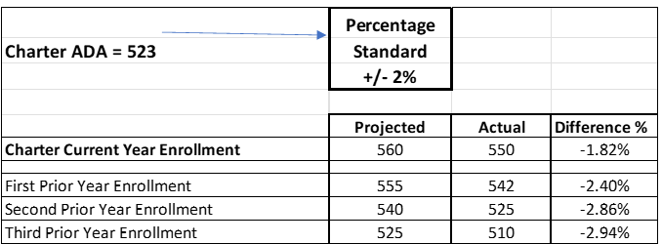
Example:

Conclusion: Does Not Meet Standard. Failed to meet the standard in two or three of the most immediate prior fiscal years based on ADA of the charter school.

4. Average Daily Attendance (ADA) to Enrollment Variance — “Is the projected funded ADA used for budgeted revenue reasonable?”
Definition: Funded ADA is a percentage based on the number of days students attended classes at second period (P2). The accuracy of projected ADA indicates to the authorizer whether the school is reasonably and conservatively budgeting revenue to fund ongoing operations. Funded ADA is the largest annual revenue source for operations. The charter historical ratio is average of the ratios from the three prior fiscal years. The percentage of variance from the charter historical ratio provides the authorizer with an indication of the school’s budgeting practices and whether it is accurately projecting ADA trends.
Data source: For charter historical ratio, official CALPADS and P2 attendance reports from three prior fiscal years. Estimated P2 ADA and enrollment from school’s projections for the current fiscal year.
Formula:
$$ADA to Enrollment Variance= \left[\frac{Projected P2 ADA}{Estimated Enrollment}\right]- Charter Historical Ratio$$
Standard
MEETS STANDARD: The projected second period (P2) ADA to enrollment ratio for any time during the current fiscal year, or two subsequent fiscal years, does not exceed the charter historical average ratio from the three prior years by more than one-half percent (.5%).
DOES NOT MEET STANDARD: Projected ratio at some time during current or next two subsequent fiscal years exceeds charter historical ratio by more than one-half percent (.5%).
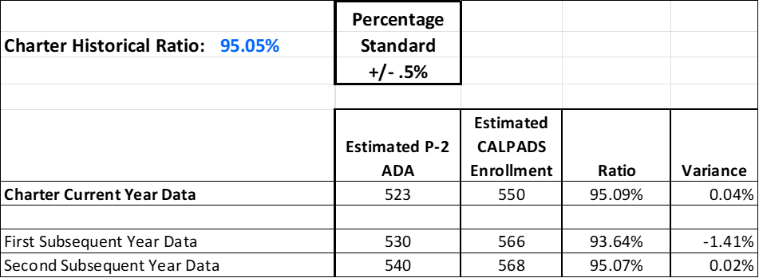
Example:

Conclusion: Does Not Meet Standard. The first subsequent fiscal year variance exceeds the historical ratio.

5. Unduplicated Pupil Percentage (UPP) Variance – “Does the school’s actual UPP funding support the operating budget?”
Definition: UPP variance is the difference between the projected and actual percentage of enrolled students as of the first Wednesday in October of each school year who qualify for Free/Reduced Price Meals, and/or are English Learners, Foster Youth, or Homeless. “Unduplicated” means that each pupil is counted only once even if the pupil meets more than one of the preceding criteria.
The accuracy of forecasted UPP indicates to the authorizer whether the school is accurately projecting its unduplicated pupil enrollment percentage, thereby generating Supplemental and possibly Concentration Grant funding the school expects to receive under the state Local Control Funding Formula.
Data source: Charter School Unduplicated Pupil Percentage on CALPADS 1.17 report.
Formula:
$$Percent Forecast Accuracy=100 x \left[\frac{Actual UPP Percentage}{Projected UPP Percentage}\right]$$
Standard:
MEETS STANDARD: Projected UPP variance equals or exceeds 95% of forecast in the current year.
DOES NOT MEET STANDARD: Projected UPP variance is less than 95% of forecast in the current year.
Example:
$$100 x \left(\frac{60\%}{65.5\%}\right)=91.6\%$$
Conclusion: Does Not Meet Standard. UPP variance is below 95% in the most recent prior year.

6. Budgeted Local Control and Accountability Plan (LCAP) — “Is the school budgeting items that mirror the approved LCAP plan and is the school’s spending so far materially consistent with the budget?”
Definition: The school’s budget as approved by the school’s governing board must include expenditures consistent with implementing the goals and actions of the school’s annual LCAP. The school should submit a brief narrative accompanying the budget highlighting how the budget supports implementation of the LCAP.
Data source: School’s approved LCAP plan, school’s budget as approved by the governing board, and accompanying budget narrative highlighting how budget supports implementation of LCAP, as well as school financial reports showing spending thus far not materially inconsistent with budget as to LCAP implementation.
Standard:
MEETS STANDARD: The approved budget is consistent with implementation of the approved LCAP, and the school’s spending so far is not materially inconsistent with the budget as to implementation of the LCAP.
DOES NOT MEET STANDARD: Any of the following are true:
- The approved budget is inconsistent with implementation of the approved LCAP.
- The adequacy of the budget to support implementation of the LCAP is inadequately explained in the accompanying budget narrative.
- The school’s spending is materially inconsistent with the budget as to implementation of the LCAP.

7. Reserve for Economic Uncertainty — “Does the school have resources to weather economic uncertainties?”
Definition: The charter school meets or exceeds the reserve level defined in the charter petition or MOU, if applicable, at each required reporting time. The reserve level is the amount of fund balance that is not reserved or obligated. If no reserve is established in the charter petition or MOU, the authorizer and charter school may consider the district reserve levels identified in Title 5 Code of California Regulations (CCR) Section 15450, based on the number of ADA.
Data sources: Official P-2 ADA , petition, MOU, Adoption Budget, Interim Reports, and Unaudited Actuals Report.
Formula: Assumes the approved petition or MOU, if applicable, follows the standard listed above. Minimum required reserve level equals the percent multiplied by total expenditures and other financing uses.
Standard:
MEETS STANDARD: Available reserves for the current fiscal year and, the two subsequent fiscal years are not less than the following percentages or amounts as applied to total expenditures and other financing uses:
- ADA Between 0 – 300: Greater of 5% or $71,000
- ADA Between 301 – 1,000: Greater of 4% or $71,000
- ADA Over 1,001: 3%
DOES NOT MEET STANDARD: Available reserves for any of the three years fall below the applicable minimum percentage for that year.

Example: Second Interim Report, ADA = 450; $ 3,000,000 in total expenditures and other financing uses; ending fund balance in unrestricted funds equals $150,000.
$$\$3,000,000 x 4\%=\$120,000$$
Conclusion: Meets Standard. School meets or exceeds the reserve level defined in the charter petition or MOU.

Sustainability Standards

1. Debt Default — “Is the school meeting its debt obligations?”
Definition: The debt default indicator addresses whether a school is meeting its loan or lease obligations or is delinquent with its debt service payments, if applicable. Based on currency of loan and/or lease payments, the school must not be in default of loan covenant(s) and must not be delinquent with debt service payments.
Data source: Notes from the audited financial statements are used as the source of data. In some cases, the MOU also may provide that the charter school disclose this information prior to entering into an agreement to incur debt. As an example of a review, the authorizer can request the most recent independent auditor's Notes to Financial Statements, and then review any Bonds Payable, Notes Payable and Leases items for detail on the specifics of debt repayment and/or the amortization schedules. The authorizer also can request a list of current year payments made to date for amounts shown as principal, interest, or lease payments.
Standard:
MEETS STANDARD: All of the following are true:
- The school’s budget, as approved by the governing board, includes expenditures to meet debt service payments.
- These expenditures are being paid on time in the current year.
- These amounts are included in the accompanying cash flow statements.
DOES NOT MEET STANDARD: Any of the above statements is not true.

2. Multi-Year Financial Projections: “Is the school living within its means?”
Definition: A Multi-Year Financial Projection (MYFP) is prepared to determine the net increase or decrease to the unrestricted ending fund balance in the subsequent two fiscal years. The budgeted net increase or decrease measures the surplus or deficit that a school is budgeted to generate from its total revenues minus expenses. The MYFP includes monthly revenue and expenditure changes to fund balance and uses historical trends and statewide assumptions to complete.
The MYFP begins with the budget of the current year with audited beginning balances and uses budget assumptions to project the subsequent two fiscal years. Net increases to the fund balance each year indicates that the school is operating within its available revenues and has a surplus available.
If positive, the school is not deficit spending by drawing down its fund balance reserve. A net decrease may indicate that the school is spending more than its budgeted revenue. A further review is needed to determine if the net decrease is for “planned spend down” (deficit spending) of ending balance carryover, or if the school instead is experiencing a structural deficit (when deficit spending exists over multiple fiscal years and is unsustainable over time).
Deficit spending occurs when current expenditures exceed current revenues. A structural deficit occurs when budgeted expenditures exceed the budgeted revenues, the excess is not a planned use of carryover, and the excess is eroding the ending fund balance reserves. A structural deficit may require adoption of a fiscal stabilization plan.
Resource: FCMAT provides a tool, Projection Pro, to prepare a MYFP, at https://www.fcmat.org/projection-pro.
Data source: Most recent current year budget, contract terms, statewide assumptions and historical trends to prepare a three-year Multi-Year Financial Projection of the current and two subsequent fiscal year budgets.
MEETS STANDARD: Over the next two subsequent fiscal years, the school is projected to have a net increase in its unrestricted fund balance, or its projected decrease in the unrestricted fund balance is for a “planned spend down” and does not represent a structural deficit.
DOES NOT MEET STANDARD: Over the next two subsequent fiscal years the school is projected to have a structural deficit depleting its unrestricted fund balance.

3. Subsequent Years Cash Flow — “How much money does the school have available to spend?”
Definition: The Cash Flow spreadsheet is a tool that compares changes in cash balances from month to month over multiple years and provides a longer-term measure of financial health and sustainability. Similar to Days Cash on Hand, this measure may include two to three years of cumulative cash flow based on revenue and expenditure trends.
The goal in preparing a cash flow is to ensure sufficient cash is available to meet financial obligations throughout the fiscal year and continuing in multiple years. Managing cash flow will allow time to manage projected cash requirements well in advance, using corrective actions if necessary to meet its financial obligation. These actions may include short- or long-term borrowing, budget reductions, delays in some obligations, and/or a spending freeze.
Data source: Beginning cash balance from the prior fiscal year should match the most recent audited balance sheet as a starting cash position; Balance Sheet, and debt amortization schedule. Some notes:
- The most recent approved budget should agree with the overall cash flow for each reporting period.
- The Balance Sheet accounts should be accurately represented (assets and liabilities), and each month should show actual charges in accounts receivable and accounts payables.
- The repayment of debt obligations should be represented.
Total cash includes the unrestricted and restricted cash balances, and aligns with the Principal Apportionment Schedule for state funding, including any state cash deferrals if provided for in legislation.
Formula:
$$Multi Year Cash Flow=Year Three Total Cash-Year One Total Cash$$
$$One Year Cash Flow=Year Two Total Cash-Year One Total Cash$$
Standard:
MEETS STANDARD: Monthly cash flows reflect positive ending cash balances based on the projected general fund revenue and expenditures, and projections appear reasonable.
DOES NOT MEET STANDARD: At least one subsequent month reflects negative ending cash balances based on the result of projected general fund revenue and expenditures, and/or projections do not appear reasonable.

Fiscal Controls

1. County Office of Education (COE) Financial Reviews – “If the COE issues letters or findings regarding the COE’s review of the school’s submitted financial reports, is the school’s governing board receiving copies of them, and is the school addressing any COE concerns?”
Definition: The COE may provide an additional level of fiscal oversight and can assist the school’s governing board members and operators with support to maintain fiscal solvency.
In addition to the authorizer’s fiscal oversight responsibility, under Education Code Section 47604.33 the charter school also must its governing board-approved budget and interim financial reports to the COE. Although not required, as a matter of practice in some counties the COE fiscal staff reviews these financial documents and prepares a letter or other statement with the results of its own review. The depth of this separate COE review may vary.
Often, these COE findings concur with the financial data and certification submitted by the charter. Other times, however, the COE may write a letter or issue findings expressing concern on one or more financial oversight areas, such as the assumptions used for the Local Control Funding Formula (LCFF), the approved Local Control and Accountability Plan (LCAP) expenditures included in the budget, or the status of corrective action on independent audit prior year findings.
The authorizer should receive and review any such COE letters or findings. A subsequent review with the charter school operators should include any response from the charter school to the COE.
Data Source: COE financial review(s) to school. Minutes from the school’s governing board recording board’s receipt of COE findings. Responses from school to COE regarding findings.
Standard:
MEETS STANDARD: The COE financial reviews do not express financial concerns about the school, or, if there are concerns, the governing board minutes record the board’s receipt of the resulting COE findings, and the board has adopted a plan to resolve the concerns in the COE findings.
DOES NOT MEET STANDARD: The COE financial findings express financial concerns about the school, and either the governing board’s minutes do not record the board’s receipt of the COE findings, and/or the board has not adopted a plan to resolve the concerns.
NOT APPLICABLE: The COE does not make it a practice to issue findings regarding the financial information it receives from charter schools in the county.

2. Annual Independent Audit — “Did the auditors provide an unqualified opinion?”
Definition: This measure is based on the independent auditor’s report and the auditor’s formal opinion and findings of material weaknesses or significant deficiencies.
Data source: Annual Audit Report pursuant to Education Code Section 47605(m).
Standard:
MEETS STANDARD: The school received either of the following:
- An Unqualified Opinion expressed by the independent auditor, or
- A Qualified Opinion but with no finding of material weaknesses or significant deficiencies.
DOES NOT MEET STANDARD: The school receives a Qualified Opinion finding a material weakness or a significant deficiency that is considered a material weakness.
Example #1:
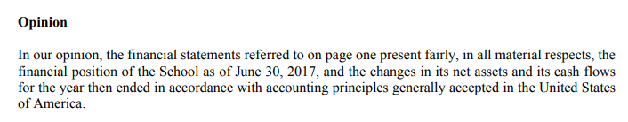
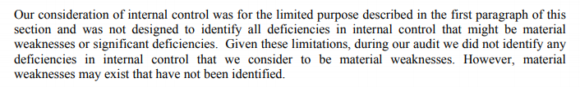
Conclusion: Meets Standard. Unqualified Opinion expressed by the independent auditor sites no material weakness or significant deficiencies.
Example #2:
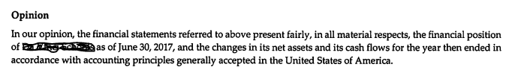
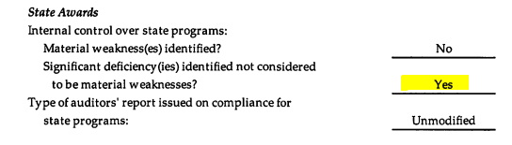
Conclusion: Does Not Meet Standard. The auditor’s opinion sites one significant deficiency not considered to be a material weakness.

FINANCIAL HEALTH AND SUSTAINABILITY: TEMPLATE

Core Question: Is the charter school financially viable?

Short-Term Indicators:

1. Days of Cash on Hand — “How many days of cash on hand does the school have to pay its bills?”
Meets |  | Does Not Meet/Falls Far Below Standard
Reviewer Comments:
Action Required? | Yes |  |  | No
Detail Required Action:

2. Cash Flow Projection: “Will cash received meet obligations each month of the budgeted fiscal year?”
Meets |  | Does Not Meet
Reviewer Comments:
Action Required? | Yes |  |  | No
Detail Required Action:

3. Enrollment Variance — “Does the projected student enrollment support the budgeted revenue?”
Meets |  | Does Not Meet
Reviewer Comments:
Action Required? | Yes |  |  | No
Detail Required Action:

4. Average Daily Attendance (ADA) to Enrollment Variance — “Is the projected funded ADA used for budgeted revenue reasonable?”
Meets |  | Does Not Meet
Reviewer Comments:
Action Required? | Yes |  |  | No
Detail Required Action:

5. Unduplicated Pupil Percentage (UPP) Variance – “Does the school’s actual UPP funding support the operating budget?”
Meets |  | Does Not Meet
Reviewer Comments:
Action Required? | Yes |  |  | No
Detail Required Action:

6. Budgeted Local Control and Accountability Plan (LCAP) - “Is the school budgeting items that mirror the approved plan and monitoring expenses?”
Meets |  | Does Not Meet
Reviewer Comments:
Action Required? | Yes |  |  | No
Detail Required Action:

7. Reserve for Economic Uncertainty — “Does the school have unrestricted resources to weather economic uncertainties?”
Meets |  | Does Not Meet
Reviewer Comments:
Action Required? | Yes |  |  | No
Detail Required Action:

Sustainability Standards

1. Debt Default — “Is the school meeting its debt obligations?”
Meets |  | Does Not Meet
Reviewer Comments:
Action Required? | Yes |  |  | No
Detail Required Action:

2. Multi-Year Financial Projections: “Is the school living within its means?”
Meets |  | Does Not Meet
Reviewer Comments:
Action Required? | Yes |  |  | No
Detail Required Action:

3. Subsequent Years Cash Flow — “How much money does the school have available to spend?”
Meets |  | Does Not Meet
Reviewer Comments:
Action Required? | Yes |  |  | No
Detail Required Action:

Fiscal Controls

1. County Office of Education (COE) Financial Report Reviews: “Is the Board receiving copies of the COE letters regarding their review of the submitted financial reports?”
Meets |  | Does Not Meet
Reviewer Comments:
Action Required? | Yes |  |  | No
Detail Required Action:

2. Annual Independent Audit — “Did the auditors provide an unqualified opinion?”
Meets |  | Does Not Meet
Reviewer Comments:
Action Required? | Yes |  |  | No
Detail Required Action:

This Toolkit is intended as a resource for authorizers. Authorizers should consult legal counsel before finalizing their templates and guidance.
CDE 2019 California School Accounting Manual, pages 810-1 through 810-4.
FCMAT California Charter School Accounting and Best Practices Manual, 2021

