Annual Report Toolkit
Introduction

April 2021
The Annual Report Toolkit is a product of CA 2.0—Advancing Equity and Access through Quality Authorizing—an initiative led by the California Charter Authorizing Professionals (CCAP).

Contents
ANNUAL REPORT TOOLKIT 1
Introduction 1
The Annual Report 2
Differentiated Oversight and the Annual Report 4
Draft for School’s Review 4
Differentiated Oversight 5
Format and Contents 7
Frameworks 7
Site Visit 7
Annual Report 7

ANNUAL REPORT TOOLKIT

Introduction
The California Charter Authorizing Professionals (CCAP) collaboratively developed a new approach to charter school authorizing, designed consistently with sound regulatory principles and recognizing the realities of this complex but important work — CA 2.0 Advancing Equity and Access trough Quality Authorizing (CA 2.0). CA 2.0’s goal is to develop a system of processes and practices that focuses on the core questions that charter authorizers must answer through their oversight of charter schools — relying on key indicators of performance instead of on rules and checklists — and that enable all authorizers to meet their responsibilities despite limited resources.
CCAP refers to these core questions as the Core Charter Performance Questions. In one form or another, the Core Charter Performance Questions guide an authorizer in all of its responsibilities: deciding whether to approve charter petitions, monitoring and reporting on a charter school’s ongoing operations, determining when and how to intervene if performance targets are not met, and deciding whether to renew. Each of these actions is bound by a set of procedures and criteria in the charter law, but these actions are fundamentally guided by the answers to the following four Core Charter Performance Questions:
- Is the charter school’s education program a success?
- Is the charter school financially viable?
- Is the charter school operating and governed effectively?
- Is the charter school advancing equity and access through serving public policy purposes?
The State Board of Education has adopted some regulations, but, unlike in other states, no official standards or specific protocols for authorizing have been developed to support all authorizers in answering the Core Charter Performance Questions. To that end, CCAP developed this Annual Report Toolkit (“the Toolkit”) to support authorizers in the fulfillment of their responsibilities to ensure that charter schools deliver a successful educational program, are financially viable, are operating and governed effectively, and serve public policy purposes by advancing equity and access in California’s public education system as a whole.

The Annual Report
The Core Charter Performance Questions are operationalized by an authorizer in its annual performance-based oversight and subsequent reporting. Reporting annually on the performance of charter schools is an essential practice for effective oversight of these schools. An annual report serves important functions. In May 2020, the Charter Accountability Resource and Support Network (CARSNet) identified three key reasons for conducting regular and ongoing school visits and evaluations: first, it allows for alignment of the criteria for renewal and the renewal review process; second, it provides an indicator of the likelihood of the school’s ability to make a compelling case for renewal; and third, it provides schools with regular feedback regarding their progress toward renewal and affords them an occasion to take early corrective action, thereby increasing the opportunities for a charter school to succeed.
Authorizers may complete the templates, or charter schools may complete sections of the templates. Ultimately, the responsibilities for data collection may be shared between the authorizer and the school.
There is consensus that the basis for an annual report is an authorizer’s performance expectations based on a set of frameworks. Indeed, the National Association of Charter School Authorizers identifies three frameworks whereby an authorizer communicates its expectations of schools in the areas of academic, financial, and organizational performance. The National Scan of Best Practices for Charter School Authorizer Accountability Tools outlined a five-step process for authorizers in the area of charter school accountability. The first two steps of the process include the authorizer establishing performance expectations and then setting corresponding standards within a performance framework. Given that expectations of performance and the frameworks that operationalize these expectations are required, yet are unique to each authorizer, this Toolkit must rely upon a set of common assumptions while accommodating the unique environments in which authorizers work.
The set of assumptions that undergird the Toolkit is found within CCAP’s CA 2.0 initiative. CA 2.0 established design principles for the initiative that are evident throughout the Toolkit. Specifically, Principle 5 positions the Annual Report (and this Toolkit) as a report that provides the foundation for renewal decisions based on the criteria in law. As a result, the Toolkit is aligned to the renewal criteria in law, and each year a charter school’s performance is measured against standards that then aggregate over time to support the authorizer and the charter school when it is time for renewal.
Additional design principles in CA 2.0 point to the charter school’s board as best positioned for overseeing the proper and successful operation of the charter school, and, therefore, the authorizer’s role should be one of broad oversight rather than management. Importantly, the Toolkit is designed to be within the capacity of all entities that serve as authorizers, especially those authorizers with fewer staffing resources. Each framework is complete while also allowing for authorizers to adapt the framework to their particular contexts. The annotatedversion of each framework provides authorizers, especially those with fewer staffing resources, with scaffolded support to enable quick integration.
Finally, the frameworks are intended to be aligned with the renewal criteria established in law. Education Code §47607 and should be considered as an authorizer establishes its performance-based oversight (i.e., answering the Core Charter Performance Questions) through the annual evaluation of a charter school’s performance. To be clear, this Toolkit is not intended to replace an authorizer’s formal processes for consideration of a charter school’s renewal application; rather, it is intended to support an authorizer in providing evidence to support a renewal application through annual performance-based oversight that is aligned to the standards and expectations of renewal. Following are the criteria for renewal and associated alignment with one or more frameworks:
- Standard for Charter Renewal: The Academic Performance Framework is specifically designed to annually measure a charter school’s academic performance against the standard for charter renewal articulated in state law. Both Dashboard Alternative School Status (DASS) and non-DASS schools are addressed in the Academic Performance Framework.
- Sound Educational Program and Capacity to Implement: Consistent with the work by CARSNet, this criterion is based on a body of evidence collected over the course of the charter school’s term (i.e., the series of annual reports). The Operations and Governance Framework and the Financial Health and Sustainability Framework include key indicators that track the school’s annual compliance with applicable laws, regulations, court orders, any applicable memorandum of understanding (MOU), and other terms described in its charter.
Summary of Resources in the Annual Report Toolkit
CA 2.0 Core Charter Performance Question | Specific Toolkit Resource
Is the education program a success? | Academic Performance Framework
Is the school financially viable? | Financial Health and Sustainability Framework
Is the school operating and governed effectively? | Operations and Governance Framework
Is the school advancing equity and access through serving public policy purposes? | Frameworks and Annual Performance Report

Differentiated Oversight and the Annual Report
Establishing performance expectations, building frameworks aligned to the expectations, and annually assessing charter schools’ performance against the expectations are prerequisite to effective oversight. How the authorizer uses the annual report to improve the quality of and access to its schools is “where the rubber meets the road.” Prior discussion within this Toolkit outlines how the Toolkit was designed to align with the renewal expectations. This section briefly discusses how an authorizer may use the annual report within the term of a charter school, each year, to engage in authentic discussions with the school on continuous improvement. A complete discussion of differentiated oversight is beyond the scope of this Toolkit; however, a brief discussion follows, upon which authorizers may build.
The term “material” is used throughout this Toolkit. As a legal term, something is material if it is relevant and significant to the outcome. In the context of this Toolkit, the authorizer should consider whether the information would be relevant and significant to decisions about whether to renew, non-renew, or revoke a charter.

Draft for School’s Review
Prior to publication, authorizers should share a final draft of the annual report with the charter school, to provide the school with an opportunity to ensure that the report is factually accurate. The authorizer should provide a reasonable timeframe for this review and should be receptive to factual corrections, should such corrections be necessary.

Differentiated Oversight
Authorizers and schools are well served when the authorizer publishes its different approaches to oversight for schools at different levels of performance. Often the term used to describe this approach is differentiated oversight and/or an intervention ladder. Of import here is the concept that a school knows what to expect as its authorizer conducts oversight and how the oversight of the school would change given its performance profile. In other words, this is autonomy for accountability operationalized.
The following table provides an example of how differentiated oversight may occur based on the performance profile of a charter school.
Oversight Level | Description | Action
Good Standing | All schools begin in Good Standing  No material breaches of their agreement (petition or MOU)  Performance on track toward renewal. | Systematic, annual monitoring
Notice of Concern | Material breach of terms and conditions of MOU or petition — this may include violation of law or regulation  Annual report identifies areas in need of significant attention (academic, financial, governance) | Formal notice of breach to school, with an opportunity provided to remedy — may impact renewal or escalate if unresolved  School required to submit plan to remedy the areas of concern  - More frequent monitoring of plan and actions by school  - Conduct site visits and/or attend governing board meetings
Ongoing Concern | Persistent, material breach(es) of terms and conditions of MOU or petition  Matters of student and staff safety  Financial distress  Escalated from Notice of Concern due to repeated noncompliance | Subsequent notice sent to school  Possible revocation  Impacts renewal decision  Significant increase in oversight requirements of the school

Format and Contents
This Toolkit is organized into three sections: Frameworks, Site Visit Protocol, and Annual Performance Report. Following are brief introductions to each of the three sections.

Frameworks
The first section introduces each of the three frameworks: Academic Performance, Operations and Governance, and Financial Health and Sustainability. Each framework section includes an introduction to help orient the authorizer, an annotated framework that walks the authorizer through each indicator and that includes a set of proposed measures with examples, and a framework template that the authorizer may modify.

Site Visit
The second section introduces the site visit in the context of oversight and positions the site visit as one aspect, along with the frameworks, of accountability and support. The site visit section describes the purpose andscope of the activities an authorizer may conduct as part of the site visit, and offers a protocol and guidance for conducting the visits.

Annual Report
The third and final section introduces the annual report to summarize the findings from the frameworks and the site visit and to report on the annual performance of the charter school. It includes an annotated annual report and a template for an authorizer to modify. Additional guidance is offered to assist authorizers in articulating performance in light of the academic tiers established in law that impact renewal decisions.
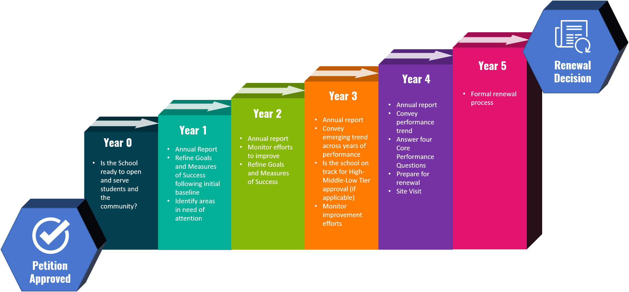

https://calauthorizers.org/wp-content/uploads/2020/12/California-Authorizing-2.0-CCAP-11192020_kwc-11.13.20-v4.pdf
This Toolkit is intended as a resource for authorizers. Authorizers should consult legal counsel before finalizing their templates and guidance.
https://www.qualitycharters.org/for-authorizers/12-essential-practices/
http://carsnet.org/wp-content/files/Published%20NorCal%20COE%20Authorizer%20Procedure%20Manual.v.5.14.2020.pdf
National Scan of Best Practices for Charter School Authorizer Accountability Tools: Performance Frameworks, Site Visit Protocols, and School Annual Reports, March 2020.
https://calauthorizers.org/wp-content/uploads/2020/04/Authorizer-Support-Action-Plan.pdf

