


Charter Renewal Toolkit
Introduction and Overview

April 2026
The Charter Renewal Toolkit is a product of
CA 2.0—Advancing Equity and Access through Quality Authorizing, an initiative of the California Charter Authorizing Professionals (CCAP).

Contents
CHARTER RENEWAL TOOLKIT 1
Introduction to the California Charter School Renewal Toolkit 1
Overview of the Authorizing Process 1
Renewal Process Overview 2
Authorizer Preparation for Renewal 3
Pre-submission Meeting Essentials Checklist 4
Submission 5
Review and Hearing 1 6
Determination 6
Getting Started: Renewal Process Checklist 8

CHARTER RENEWAL TOOLKIT

Introduction and Overview
The charter petition renewal process is a critical milestone for California’s charter schools, influenced by still evolving laws such as Assembly Bill 1505 (2019) and the aftermath of COVID-19 pandemic-related charter term extensions, which delayed some charter renewals by up to eight years. This toolkit offers a high-level framework to help authorizing agencies navigate the renewal process efficiently while ensuring compliance and transparency with educational partners.
The Renewal Toolkit includes five key sections:
- This Renewal Process Introduction and Overview: A concise, step-by-step guide covering each phase, from petition submission to public hearing.
- Renewal Internal Action Plan: An internal planning document to assist the authorizer in preparing for the renewal process by compiling initial information on its charter school(s) in quick reference form.
- Data Preparation Guidance: A summary of performance data requirements from the California Department of Education (CDE) and State Board of Education (SBE).
- Review Process: An outline of the evaluation process, aligned with CCAP’s Oversight Framework and Annual Performance Progress Report.
- Findings of Fact: Guidance on preparing, and samples of, the Staff Report, the Board Resolution, the Notice of the Public Hearing, and the Board Meeting Agenda item for processing a Renewal Petition.

In addition, the Renewal Toolkit also includes several related Renewal “Grab and Go” Tools:

- Charter Renewal Intake Information Checklists: A tool to help charter school petitioners check their petition before submitting it and for authorizers to check its completeness and legal compliance upon receiving it.
- Master Petition Review Rubric: A tool to help authorizers review a charter petition, deisgned for a new school petition but also usable for checking the required elements of a renewal petition.
- Traditional Charter Renewal Review Committee Report Template: A template report for the renewal committee to complete on a petition for a non-Dashboard Alternative School Status (DASS) school.
- DASS Charter Renewal Review Committee Report Template: A template report for the renewal committee to complete on a petition for a DASS school.
Designed to support the entire charter lifecycle, this toolkit complements CCAP’s 2024 Annual Report Toolkit 2.0 and offers customizable “Grab and Go Tools” that can be tailored to local authorizer needs.

Overview of the Authorizing Process
Ordinarily the authorizing process encompasses three phases: the initial petition, annual oversight, and renewal. Renewal evaluation for a charter term begins upon a school’s renewal, emphasizing continuous improvement, legal compliance, and regular engagement with school leaders.
Rooted in the California Education Code and aligned with board policies, CCAP’s framework for the charter authorizing and oversight process is driven by four guiding questions:
- Is the charter school’s education program a success?
- Is the charter school financially viable?
- Is the charter school operating and governed effectively?
- Ultimately, is the charter school serving public policy purposes?
This framework serves as a resource for school districts and county authorizers of charter schools, charter school governing boards, administrators, and the public to address the diverse needs of California's charter schools and the educational needs of their students, families, and local communities.
Oversight is designed to be transparent and collaborative, including, but not limited to:
- Information and action at public meetings
- Desk audits of documents and website compliance
- Fiscal reviews verifying institutional integrity and viability
- Ongoing progress monitoring and
- Site visits to validate claims through program observations and discussions
Charter school leaders and governing boards remain responsible for full legal compliance, while the authorizer verifies and/or validates information and provides a transparent record of the school’s progress toward renewal.

Renewal Process Overview
Required elements of the renewal process are annotated with an asterisk (*) for ease of reference. Asterisks do not necessarily indicate all parts of the item are required. For example, the Education Code requires a review of the petition, but it does not dictate that a “committee” must perform the review.
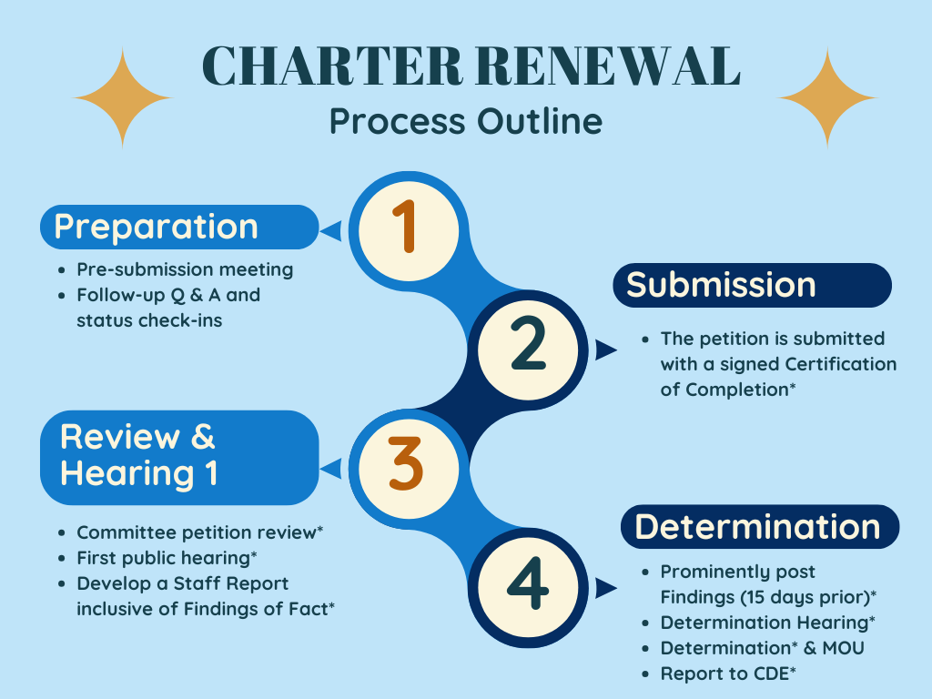

Authorizer Preparation for Renewal
- Develop Relationships: Build working relationships with charter school leaders to provide guidance on best practices and petition submission timing.
- Hold Pre-Submission Meetings: Conduct meetings with the authorizer’s designated charter contact, other authorizing staff if any, and potentially additional support (e.g., fiscal or education program staff) to ensure high-quality petition submissions.
- Align Local Context with Legal Requirements: Although small organizations may lack dedicated teams, avoid relying on a single individual for petition review. Leverage staff and/or external expertise and assign qualified individuals to specific review areas to ensure the authorizing board receives accurate and adequate information regarding submission compliance.
- Designate a Review Committee: Although small organizations may lack dedicated teams, avoid relying on a single individual for petition review. Leverage staff expertise and assign qualified individuals to specific review areas to ensure the authorizing board receives accurate and adequate information regarding submission compliance.
For organizations without dedicated staff or a charter department, establish a review committee, including a designated chair and qualified staff. Set expectations for communication and confidentiality. Review mandated timelines and procedures. Exercise caution in this process as staff members may be called upon to interact directly with the superintendent, the board, and/or legal counsel in contentious situations. Consider using support staff to assist with data collection and report formatting, provided confidentiality can be maintained. Another option is to retain one or more external reviewers to complement internal capacity where helpful.
For organizations with dedicated charter staff or a charter department, collaboratively establish timelines and workflows, and identify potential barriers (e.g., who will review special education if no one on the team has special education knowledge?).
- Review Committee Training: Bring the committee together to discuss the statutory timeline and provide a “balcony view” of the process, including an introduction to or revisit of any review tools, and expectations regarding confidentiality and communication.
- Establish Early Data Collection: As best practice, and to relieve pressure from the renewal timeline, establish a data collection system as part of the annual oversight process. The state and local data collection necessary for renewal are embedded in the CCAP’s Annual Oversight Toolkit.

Pre-submission Meeting Essentials Checklist
- Pre-Planning Time
- Allow ample time for the charter school to request inclusion on the next SBE quarterly agenda after the renewal process, in the event of an appeal.
- Outline a timeline of key events based on the tentative submission date.

- Document Submission Reminders and Requests
- Ask the school to provide a redlined copy of all substantive changes to the petition.
- Ask the school to include in an executive summary or introduction with:
  - A description of all changes (recommend a two-column table by element); and
  - A performance summary of the concluding charter term.
- Remind the school of the following:
  - The prior performance should include an update on measurable pupil outcomes from the petition’s Element 2.
  - All data claims must be valid and verifiable.
  - Supporting documentation must be provided in the appendix.
  - Student-level data or student-group data with fewer than 11 students should not be submitted.
  - Reported data should include student groups with with 30 or more students, and for Verified Data, groups with more than 10 students.
  - Reported data for students classified as foster/homeless must be reported when 15 or more students.

- Petition Update Reminders
- It is the school’s responsibility to ensure that the petition reflects all legal updates since its last approval.
- All descriptions should be comprehensive.
- Do not assume prior approval means the petition is comprehensive. Schools change; so should the petition.

- Follow-up
- Schedule meetings at regular intervals to allow time for Q&A and troubleshooting prior to submission.
- CAUTION: Stay in your lane. Do not revise or write any portion of the charter.
- Encourage the charter school to obtain the approval of its governing board before submission.
- Encourage the charter school to seek legal counsel on charter development, as needed.
- Aple Time

Submission
- Understand Legal Requirements: Ensure the petition includes a signed Certification of Completion. No other legal requirements exist for submission; however, early renewal submissions and material revisions will require additional processes, as further described in the: Review Process document in this Renewal Toolkit.
- Attend to the Delivery Process: The petition may be delivered to the authorizing board’s public meeting, the superintendent, the designated charter contact, or any other person within the organization. Maintain frequent communication to ensure timely and accurate delivery to the chair of the review committee that was described in the Preparation section above.
- Initiate the Timeline: The mandated timeline for a board decision begins once the petition is delivered with the signed Certification of Completion. This timeline does not account for or allow for holidays, personal time off, or other mandated timelines. Establish and calendar all key dates, mapping backwards from 90 days.

Review and First Hearing
- Assemble the Review Committee: Communicate the anticipated submission date with the committee as early as possible, so team members can leave space in their calendars for the work. As soon as the petition is submitted, finalize the timeline, schedule key dates, and distribute materials to committee members to begin the review process.
- Schedule Committee Check-Ins: Based on staffing size and roles, schedule check-ins (at least two are recommended). The first check-in should occur within the first few weeks to ensure that all team members are actively reviewing the submission and to debrief on initial perceptions of the submitted petition. Schedule the second check-in to debrief fully on the review findings, but leave enough time to finalize the Staff Report, including the required findings of fact. If time and staffing permit, additional meetings can be added to the schedule.
- Schedule the First Public Hearing: Coordinate with the superintendent’s office early to set the first hearing date to occur within the statutory 60-day timeline and avoid creating unnecessary special meetings.
- Draft or Update a Memorandum of Understanding (MOU): An MOU between the authorizer and the charter school is not required, but this tool is very commonly used to clarify the respective roles and responsibilities of the charter school and the authorizer, particularly regarding reporting, oversight, and operational expectations throughout the term of the charter. It also is common practice, but not a legal requirement, for the authorizing board to condition its approval of the petition on the charter school’s execution of the MOU. Visit the CCAP’s online Resource Library for the Memorandum of Understanding (MOU) Resource: Samples and Cross Reference.
- Understand the Local Context: Clarify roles in the public posting and hearing process (e.g., introducing agenda items) based on established local practices. Obtain necessary templates and internal deadlines for post-hearing reports and findings of fact. Identify the individual(s) responsible for website postings.
- Communicate with the Charter School: Share information about the authorizing board’s expectations for any presentations, public comment, and other relevant details with the charter school.

Determination
- Preview the Draft Staff Report: Some authorizers prefer to meet with and discuss or allow the charter school to preview the draft Staff Report, allowing the school to seek clarification on recommendations or findings and to identify possible factual errors.
- Post the Final Staff Report: Publish the Staff Report, inclusive of required findings of fact on the authorizing agency’s webpage, no fewer than 15 days before the determination. No substantive changes should be made once posted.
- Hold the Determination Hearing: Authorizing agency staff present the findings of fact to the authorizing board. By law, the charter school may respond with a presentation of equal time and procedures, as provided to the authorizing agency. This process allows board members to seek clarification before deciding to approve or deny the petition.
While uncommon, the hearing may be placed on the same agenda as the determination, but if so, it must precede the action item.
- Make the Determination: Within 90 days of the renewal petition’s submission, the authorizing board must grant or deny the petition.
- Take Post-Decision Actions: If approved, update and finalize the MOU with any adjustments made by the authorizing board and obtain signatures from both parties. Report the renewal term or denial to the CDE’s Charter Schools Division, as outlined on the Department’s Charter School Renewals web page. If denied, work with the charter school on closure proceedings as outlined in the approved charter and any MOU, and/or prepare for an appeal process. This process is described in more detail in the Petition Review Guide in this Renewal Toolkit.

Getting Started: Renewal Process Checklist
1. PREPARATION
☐ | Establish review committee roles/expectations (confidentiality, workflow, timelines, and systems)
☐ | Meet with the review committee for early training and discussion.
2. SUBMISSION
☐ | Review the submission for a signed and dated Certification of Completion.
☐ | Know where and when the school intends to submit.
☐ | Backwards map a final timeline from the submission date. Consider the statute and meeting schedule.
3. REVIEW AND HEARING 1
☐ | Share the petition with the committee and the superintendent/board.
☐ | Assign petition elements for review.
☐ | Schedule the first public hearing; clarify local procedures with the superintendent’s office.
☐ | Draft an MOU.
☐ | Share public comment expectations with the school.
4. DETERMINATION HEARING
☐ | Prominently post the Staff Report with findings at least 15 days prior to the determination.
☐ | Prepare the agenda item.
☐ | Post determination: Follow up with CDE on approval/denial. See the CDE Charter Division website.

