



ANNUAL REPORT TOOLKIT
Introduction
September 2024
The Annual Report Toolkit is a product of CA 2.0—Advancing Equity and Access through Quality Authorizing, an initiative led by the California Charter Authorizing Professionals (CCAP). WestEd's support in the initial development of the 2021 Toolkit is appreciated.

Contents
ANNUAL REPORT TOOLKIT 1
Introduction 1
The Annual Report 1
Adaptation for Local Context 3
Differentiated Oversight and the Annual Report 4
Draft for School’s Review 4
Differentiated Oversight 5
Format and Contents 6
Performance Frameworks 6
Site Visits 6
Annual Performance Progress Report, Template and Tools 6
Grab and Go Templates 6

Annual Report Toolkit © 2024 by California Charter Authorizing Professionals is licensed under CC BY 4.0. To view a copy of this license, click here.

ANNUAL REPORT TOOLKIT

Introduction
The California Charter Authorizing Professionals (CCAP) collaboratively developed a new approach to charter school authorization, designed consistently with sound regulatory principles and recognizing the realities of this complex but important work—CA 2.0 Advancing Equity and Access through Quality Authorizing (CA 2.0). CA 2.0’s goal is to develop a system of processes and practices that focuses on the core questions that charter authorizers must answer through their oversight of charter schools—relying on key indicators of performance instead of rules and checklists—and that enable all authorizers to meet their responsibilities despite limited resources.
CCAP refers to these core questions as the ‘core charter performance questions.’ In one form or another, these questions guide an authorizer in its responsibilities: deciding whether to approve charter petitions, monitoring and reporting on a charter school’s ongoing operations, determining when and how to intervene if performance targets are unmet, and deciding whether to renew. Each of these actions is bound by a set of procedures and criteria in the charter law, but these actions are fundamentally guided by the answers to the following four core charter performance questions:
- Is the charter school’s education program a success?
- Is the charter school financially viable?
- Is the charter school operating and governed effectively?
- Is the charter school advancing equity and access by serving public policy purposes?

The State Board of Education has adopted some regulations, but unlike in other states, no official standards or specific protocols for authorizing have been developed to support all authorizers in answering the core charter performance questions. To that end, CCAP developed this Annual Report Toolkit (“the Toolkit”) to support authorizers in the fulfillment of their responsibilities to ensure that charter schools deliver a successful educational program, are financially viable, are operating and governed effectively, and serve public policy purposes by advancing equity and access in California’s public education system as a whole.

The Annual Report
There are three widely accepted reasons for conducting regular and ongoing school visits and evaluations: first, it allows for alignment of the criteria for renewal and the renewal review process; second, it provides an indicator of the likelihood of the school’s ability to make a compelling case for renewal; and third, it provides schools with regular feedback regarding their progress toward renewal and affords them an occasion to take early corrective action, thereby increasing the opportunities for a charter school to succeed.
There is consensus that the basis for an annual report is an authorizer’s performance expectations based on a set of frameworks. The National Association of Charter School Authorizers identifies three frameworks whereby an authorizer communicates its expectations of schools in academic, financial, and organizational performance, and The National Scan of Best Practices for Charter School Authorizer Accountability Tools outlines a five-step process for authorizers in charter school accountability. The first two steps of the process include the authorizer establishing performance expectations and then setting corresponding standards within a performance framework. Given that expectations of performance and the frameworks that operationalize these expectations are required yet are unique to each authorizer, this Toolkit must rely upon a set of shared assumptions while accommodating the unique environments in which authorizers work.
The term “material” is used throughout this Toolkit. As a legal term, something is material if it is relevant and significant to the outcome. In the context of this Toolkit, the authorizer should consider whether the information would be relevant and significant to decisions about whether to renew, non-renew, or revoke a charter.
An authorizer operationalizes the core charter performance questions in its annual performance-based oversight and subsequent reporting. Authorizers may complete the accompanying templates, or charter schools may be asked to complete portions. Ultimately, the responsibilities for data collection may be shared between the authorizer and the school.
An Oversight Framework is available to support authorizers in establishing local procedures aligning with established best practices.
A charter school’s annual performance is measured against standards that aggregate over time to support the authorizer and the charter school when it is time for renewal. Reporting annually to the authorizing board on each charter school's performance is essential for effective oversight.
The assumptions underlying the Toolkit are found within CCAP’s CA 2.0 initiative. CA 2.0 established design principles for the initiative that are evident throughout the Toolkit. Specifically, Principle 5 positions the Annual Report (and this Toolkit) to provide the foundation for renewal decisions based on the criteria in law.
Additional design principles in CA 2.0 point to the charter school’s board as best positioned for overseeing the proper and successful operation of the charter school, and, therefore, the authorizer’s role should be one of broad oversight rather than management. Notably, the Toolkit is designed to be within the capacity of all entities serving as authorizers, especially those with fewer staffing resources. As previously noted, Frameworks can be adapted to local context, and annotated versions of each framework provide authorizers with scaffolded support to enable quick integration. However, frameworks are intended to align with the renewal criteria established in law, and Education Code §47607 should be referenced when establishing performance-based oversight (i.e., answering the Core Charter Performance Questions) through annual evaluation of a charter school’s performance.

Adaptation for Local Context
While the Annual Performance Progress Report and Frameworks are aligned directly with the established renewal criteria in the law, authorizers may adapt them to fit their local context. A note of caution is warranted given the clarity of renewal standards in the statute: Authorizers are advised to ensure their annual performance-based oversight and the generation of annual reports that include an assessment of academic performance are consistent with renewal standards. Adding elements or unique weighting of indicators that result in an authorizer reporting a charter school is in “good standing” when the same level of performance by the school places it in the “Low Level” eligibility under the statutory standard for renewal is problematic. Alternatively, an authorizer reporting a charter school’s educational program is not successful when the same level of performance by the school places it in the “High Level” eligibility under the statutory standard for renewal is problematic. Such disagreement between “yardsticks” is a disservice to the school, the public, the students, and the authorizer. When expectations are properly aligned, they provide for continuity and support cycles of continuous improvement that are more likely to culminate in responsible, high-stakes decisions. The guidance and framework assume the majority of the data collection and reporting is the responsibility of the authorizer. However, authorizers may direct charter schools to complete specific sections of the framework for input into the final report.
To be clear, this Toolkit is not intended to replace an authorizer’s formal processes for consideration of a charter school’s renewal application; rather, it is intended to support an authorizer in providing evidence to support a renewal application through annual performance-based oversight that is aligned to the standards and expectations of renewal. The following points summarize the criteria for renewal and associated alignment with one or more frameworks:
- Standard for Charter Renewal: The Academic Performance Framework measures a charter school’s academic performance annually against the standard for charter renewal articulated in state law. The framework addresses Dashboard Alternative School Status (DASS) and non-DASS schools.
- Additional Evidence: A body of evidence is collected over the charter school’s term (i.e., the series of annual reports). The Performance Frameworks include key indicators that track the school’s annual compliance with applicable laws, regulations, court orders, any applicable memorandum of understanding (MOU), and other terms described in its charter.
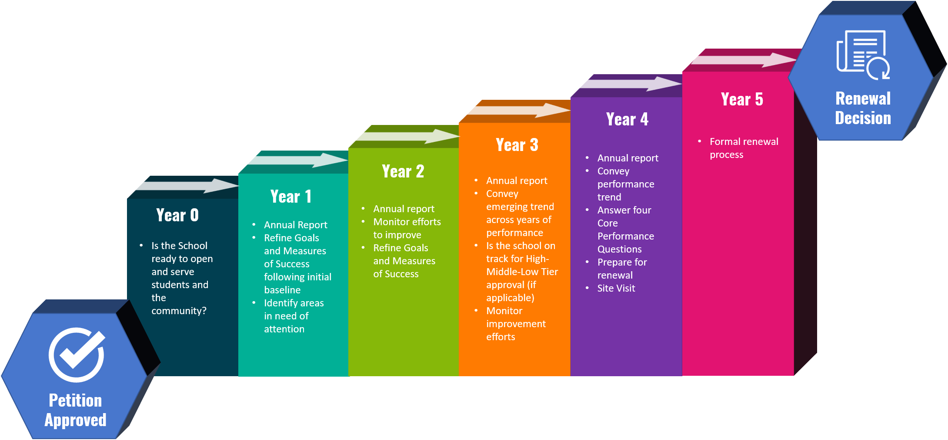
- The following image outlines a standard oversight process from Year 0 through renewal.

Differentiated Oversight and the Annual Report
Establishing performance expectations, building local procedures aligned to the expectations, and annually assessing charter schools’ performance against the expectations are best practices for effective oversight. How the authorizer uses the annual report to improve the quality of and access to its schools is “where the rubber meets the road.” Prior discussion within this Toolkit outlines how it is designed to align with the renewal expectations. This section briefly discusses how an authorizer may use the annual report within the term of a charter school each year to engage in authentic discussions with the school on continuous improvement. A complete discussion of differentiated oversight is beyond the scope of this Toolkit.

Draft for School’s Review
As best practice, authorizers should share a final draft of the annual report with the charter school before publication to allow the school to ensure that the report is factually accurate. The authorizer should provide a reasonable timeframe for this review and be receptive to factual corrections, should such corrections be necessary.

Differentiated Oversight
Authorizers and schools are well served when the authorizer publishes different approaches to overseeing schools at different performance levels. The term used to describe this approach is often ‘differentiated oversight’ and/or an ‘intervention ladder.’ Given its performance profile, a school must know what to expect as its authorizer conducts oversight and how the school's oversight would change. In other words, this is autonomy for accountability operationalized.
The following table demonstrates how differentiated oversight may occur based on a charter school's performance profile.
Oversight Level | Description | Action
Good Standing | All schools begin in Good Standing  No material breaches of their agreement (petition or MOU)  Performance on track toward renewal. Strengths are documented. | Systematic, annual monitoring
Differentiated Monitoring | Some action/correction may be necessary but will not rise to the Notice of Concern level. The annual report documents all required actions. | Systematic, annual monitoring  A timeline is established for each required action/correction.  A plan addressing future action may be required (e.g., addressing low achievement rates).  - School plans and actions monitored  - Conduct site visits and/or attend governing board meetings
Notice of Concern | A material breach of terms and conditions of MOU or petition — this may include violation of law or regulation.  The annual report identifies areas of strength that need significant attention (academic, financial, governance) and all required actions. | Formal notice of breach to school, with an opportunity provided to remedy — may impact renewal or escalate if unresolved  Schools are required to submit a plan to remedy the areas of concern  - More frequent monitoring of plans and actions by the school  - Conduct site visits and/or attend governing board meetings
Ongoing Concern | Persistent, material breach(es) of terms and conditions of MOU or petition  Matters of student and staff safety  Financial distress  Escalated from Notice of Concern due to repeated non-compliance | Subsequent notice was sent to the school  Possible revocation  Impacts renewal decision  Significant increase in oversight requirements of the school

Format and Contents
This Toolkit is organized into four sections:

Performance Frameworks
The first section introduces the Performance Frameworks: Academic, Financial Health and Sustainability, Operations and Governance, and Public Policy. Each framework section includes an introduction to help orient the authorizer and an annotated framework that walks the authorizer through each indicator.

Site Visits
The second section introduces site visits in the context of oversight. This section describes the purpose and scope of an authorizer's activities before and during the site visit and offers a protocol and guidance for conducting the visits. The site visit is an extension of the authorizer’s oversight. It is used to gather evidence of compliance and performance to inform the annual report and the school’s trajectory toward renewal that could not be collected by desk audit alone (e.g., interviews with school staff, students, parents/guardians, and onsite records reviews).

Annual Performance Progress Report, Template and Tools
The third section introduces the annual report, summarizing key indicator findings, the site visit, and the charter school's annual performance progress. Additionally, an Oversight Framework was added to provide a model for authorizers establishing annual oversight expectations to align with the Annual Report.

Grab and Go Templates
The final section contains report and checklist templates that can support the collection of information needed to populate the Annual Report. These templates and tools are formatted and ready for use.

https://calauthorizers.org/wp-content/uploads/2020/12/California-Authorizing-2.0-CCAP-11192020_kwc-11.13.20-v4.pdf
This Toolkit is intended as a resource for authorizers. Authorizers should consult legal counsel before finalizing their templates and guidance.
http://carsnet.org/wp-content/files/Published%20NorCal%20COE%20Authorizer%20Procedure%20Manual.v.5.14.2020.pdf
National Scan of Best Practices for Charter School Authorizer Accountability Tools: Performance Frameworks, Site Visit Protocols, and School Annual Reports, March 2020.
https://calauthorizers.org/wp-content/uploads/2020/04/Authorizer-Support-Action-Plan.pdf
https://www.qualitycharters.org/for-authorizers/12-essential-practices/

