Safety Checklist
Verified | Description | Reviewer Notes
 | The School Safety Plan is current and contains, at a minimum, the elements required of a charter school. A Comprehensive Safety Plan is best practice.
 | The Illness & Injury and Workplace Violence Prevention Plan is current.

Personnel Records Checklist
Verified | Description | Reviewer Notes
 | Three sample employment contracts
 | Documentation of Tuberculosis Test results
 | Certificates of AB 1432 Training
 | Certificates of Anti-Harassment Training (As Applicable)
 | Certificates of Training for Serving Youth Experiencing Homelessness (As Applicable)
 | Three Sample Teacher Evaluations
 | Documentation of Qualifications Held by Classified Aides
 | Certificates of Training for School Security Officers or Guards
 | Verification of appropriate assignment comparing the teacher’s schedule to their credentials

Special Education Student Records Checklist

Option 1
This set of tables contains images that are not editable.
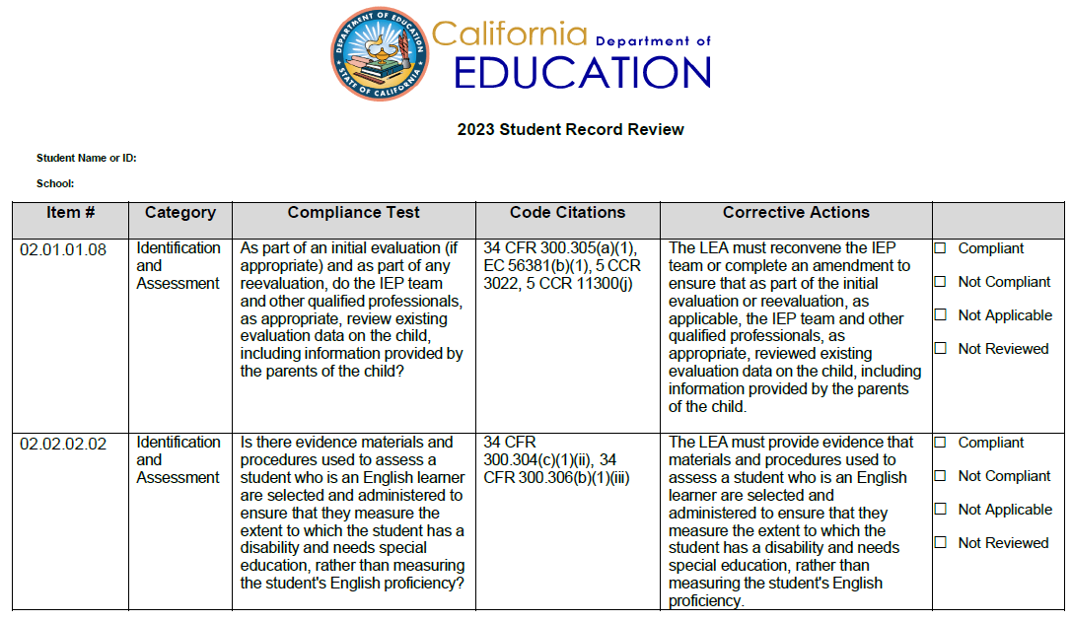

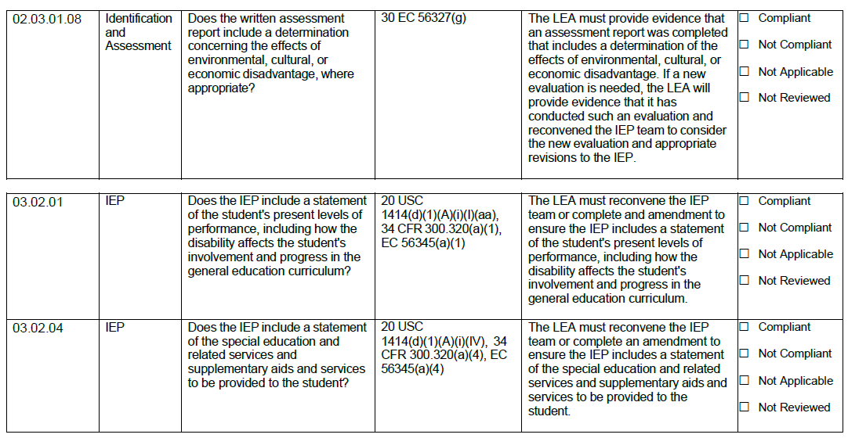

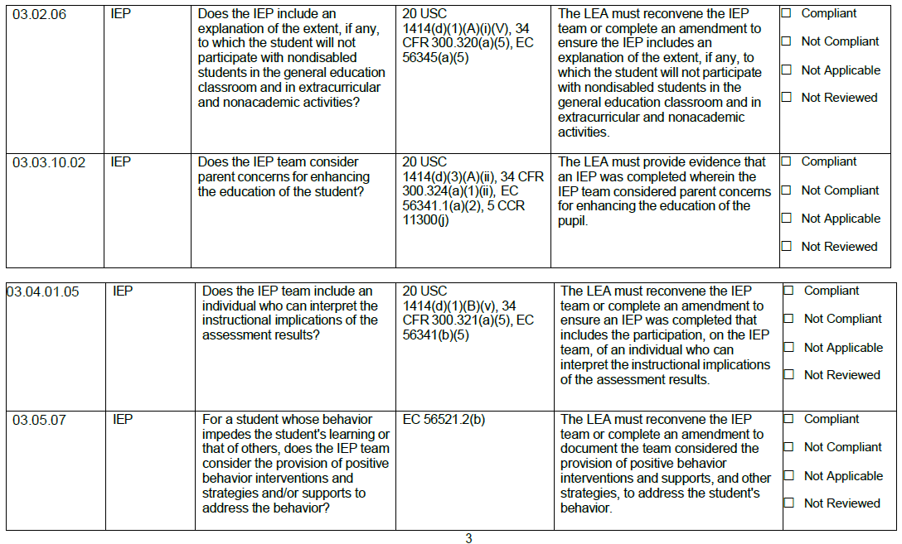

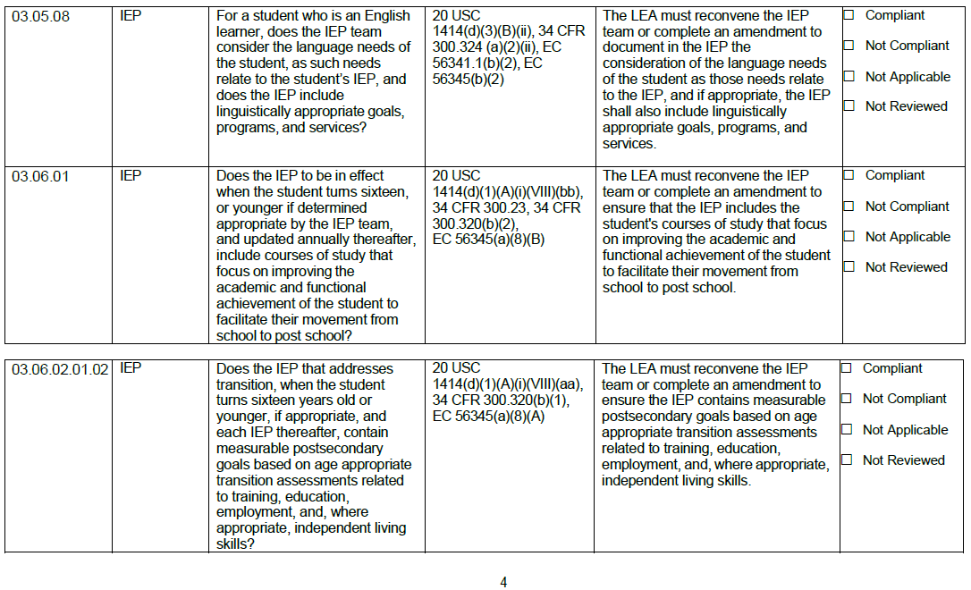

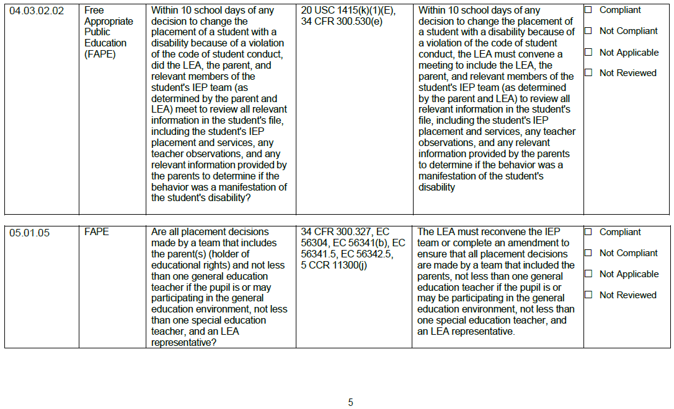

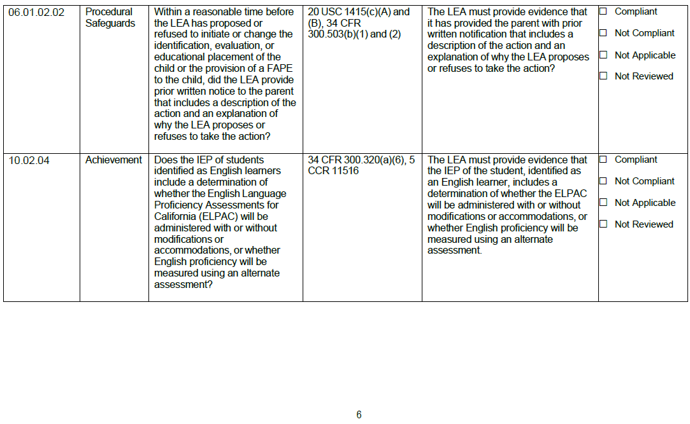

Option 2
Credit: CA Special Education Technical Assistance Network
Policy, Procedure, and Practices Review Protocols
Item  Number | Compliance Test | Compliant | Non-Compliant | Not Applicable | Not Relevant
Indicator 9, Indicator 10, Placement & Discipline (Disproportionality)
2-2-2.6  Ind 9, Ind 10,  Placement and  Discipline | Is there evidence that the current assessment is comprehensive and that assessments were administered in all areas related to the suspected disability by trained and knowledgeable personnel using sound instruments?
2-3-1.6  Ind 9, Ind 10,  Placement and  Discipline | Does the written Assessment Report include relevant behavior noted during observation of the student in the appropriate setting?
2-3-1.8  Ind 9, Ind 10,  Placement and  Discipline | Does the written Assessment Report include determining the effects of environmental, cultural, or economic disadvantage, where appropriate?
2-4-1  Ind 9, Ind 10,  Placement and  Discipline | Does a reevaluation occur unless the parent and the LEA agree that a reevaluation is unnecessary: a) not more frequently than once a year; b) at least every three years; c) when the LEA determines that the educational or related service needs (including improved academic achievement and functional performance) warrant an evaluation; or d) at the student's parents or teacher request?
3-3-6.1  Ind 9, Ind 10,  Placement and  Discipline | Does the IEP team periodically review but, not less frequently than annually, the student’s IEP, including progress toward annual goals and progress in the general curriculum when developing new goals?
3-3-10.2  Ind 9, Ind 10,  Placement and  Discipline | Does the IEP team consider parent concerns for enhancing the student's education?
3-4-2.1  Ind 9, Ind 10,  Placement and  Discipline | Did the IEP team use various sources of information, such as tests, teacher recommendations, and parent input, to determine eligibility?
3-5-7  Ind 9, Ind 10,  Placement and  Discipline | Does the IEP team consider providing positive behavior interventions, strategies, and/or supports to address a student's or others' learning impediment?
5-1-5  Ind 9, Ind 10,  Placement and  Discipline | Are all placement decisions made by a team including the parents and not less than one general education teacher, one special educator, and an LEA representative?
2-3-1.2  Ind 9, Ind 10,  Placement and  Discipline | Does the written Assessment Report include the results of tests administered in the student's primary language by qualified personnel?
3-5-8  Ind 9, Ind 10,  Placement and  Discipline | Does the IEP team consider the language needs of students with limited English proficiency (English language learners), as such needs relate to the student’s IEP, and does the IEP include linguistically appropriate goals, programs, and services?
Indicator 9 (Disproportionality)
2-2-2.5  Indicator 9 | Are testing and assessment materials and procedures selected and administered so as not to be racially or culturally discriminatory?
Indicator 10 (Disproportionality)
10-2-4  Indicator 10 | Does the IEP of students identified as English learners include determining whether the ELPAC will be administered with or without modifications or accommodations or whether English proficiency will be measured using an alternate assessment?
Discipline (Disproportionality)
4-3-1  Discipline | When a student with a disability is removed from his or her current placement for ten (10) school days in the same school year, did the public agency provide services during any subsequent days of removal?
4-3-3  Discipline | Did the IEP team consider all required elements in making the manifestation determination?

Item  Number | Compliance Test | Compliant | Non-Compliant | Not Applicable | Not Relevant
Placement (Disproportionality)
3-2-1  Placement | Does the current IEP include a statement of the student's present performance levels, including how the disability affects the student's involvement and progress in the general curriculum?
3-2-6  Placement | Does the IEP include an explanation of the extent, if any, to which the student will not participate with general education students in the general education classroom and extracurricular and nonacademic activities?
5-1-5.1  Placement | Are all placements determined annually, made as close as possible to the student's home, and in the school the student would attend if nondisabled unless the IEP team determines otherwise?
5-1-5.2 Placement | In selecting the LRE, is consideration given to any potential harmful effect of the placement on the child or the quality of services that he or she needs?
SPPI- T (Targeted)
3-2-3  SPPI-T (all) | Does the IEP include a direct relationship between the present performance levels, goals, and the specific educational services to be provided?
Grad Rate (Targeted)
3-6-1  Grad Rate | Does the IEP to be in effect when the student turns sixteen or younger if determined appropriate by the IEP team, and updated annually thereafter, include courses of study that focus on improving the academic and functional achievement of the student to facilitate their movement from school to post-school?
3-6-2.1  Grad rate | Does the IEP to be in effect when the student turns sixteen or younger, if determined appropriate by the IEP team, and updated annually thereafter, include appropriate measurable postsecondary goals based upon age-appropriate transition assessments?
Indicator 2 (Targeted)
3-6-2.1.2  Grad rate | Does the IEP that addresses transition when the student turns sixteen years old or younger, if appropriate, and each IEP thereafter, contain measurable postsecondary goals based on age-appropriate transition assessments related to training, education, employment, and, where appropriate, independent living skills?
ELA and Math Academic Performance (Targeted)
3-2-8.1  ELA and Math  Academic  Performance | Does the IEP include a statement of any appropriate accommodations necessary to measure the student's academic achievement and functional performance on LEA and statewide assessments?
3-2-8.2  ELA and Math  Academic  Performance | Does the IEP include a statement regarding participation in LEA or statewide achievement tests and explain why it is not appropriate for the student to participate in general education LEA or statewide achievement tests, if the IEP team makes that decision?
Suspension (Targeted)
3-4-1.2.1.1  Suspension | Does the general education teacher, to the extent appropriate as a member of the student’s IEP team, participate in the determination of a) appropriate positive behavioral interventions and supports and other strategies for the student, b) supplementary aids and services, c) program modifications; and d) supports for school personnel?
Indicator 5 (Targeted)
5-1-3.3  Indicator 5 | Does the IEP team consider the general education classroom with designated instruction and services or related services as part of the continuum of services and placements?
Indicator 6 (Targeted)
3-4-1.5  Indicator 6 | Does the IEP team include an individual who can interpret the instructional implications of the assessment results?
7-4-2.1  Indicator 6 | Does the IEP for the preschool student include a statement of the student’s present levels of academic achievement and functional performance, including how the disability affects the student’s participation in appropriate activities?
7-4-2.5  Indicator 6 | Does the IEP for the preschool student include an explanation of the extent, if any, to which the student will not participate in the general education preschool class and extracurricular and non-academic activities?
7-4-3  Indicator 6 | If the student participates in or may participate in a general education environment, does the IEP team include at least one general education teacher?

Item  Number | Compliance Test | Compliant | Non-Compliant | Not Applicable | Not Relevant
Indicator 8 (Targeted)
2-1-1.8  Indicator 8 | As part of an initial evaluation (if appropriate) and any reevaluation, do the IEP team and other qualified professionals, as appropriate, review existing evaluation data on the child, including information provided by the child's parent(s)?
Indicator 14 (Targeted)
3-6-2.5  Indicator 14 | Does the first IEP to be in effect when the student turns sixteen or younger if determined appropriate by the IEP team, and each IEP thereafter include the needed transition services (i.e., a coordinated set of activities) that includes (a) instruction; (b) related services; (c) community experiences; (d) the development of employment and other post-school objectives; and (e) when appropriate, acquisition of daily living skills and provision of a functional vocational evaluation?
3-6-5  Indicator 14 | Does the LEA provide the student whose eligibility was terminated due to graduation from secondary school with a regular diploma or due to exceeding the age of eligibility for FAPE with a summary of the student’s academic achievement and functional performance that includes recommendations on how to assist the student in meeting the student’s postsecondary goals?
SPPI -I (Intensive)
2-1-1.8  SPPI-I | As part of an initial evaluation (if appropriate) and any reevaluation, do the IEP team and other qualified professionals, as appropriate, review existing evaluation data on the child, including information provided by the child's parent(s)?
2-2-2.2  SPPI-I | Are there evidence materials and procedures used to assess a student who is an English learner selected and administered to ensure that they measure the extent to which the student has a disability and needs special education rather than measuring the student's English proficiency?
3-2-4  SPPI-I | Does the IEP include a statement of the special education and related services and supplementary aids and services to be provided to the student?
3-4-1.5  SPPI-I | Does the IEP team include an individual who can interpret the instructional implications of the assessment results?
3-6-1  SPPI-I | Does the IEP to be in effect when the student turns sixteen or younger if determined appropriate by the IEP team, and updated annually thereafter, include courses of study that focus on improving the academic and functional achievement of the student to facilitate their movement from school to post-school?
3-6-2.1.2  SPPI-I | Does the IEP that addresses transition when the student turns sixteen years old or younger, if appropriate, and each IEP thereafter, contain measurable postsecondary goals based on age-appropriate transition assessments related to training, education, employment, and, where appropriate, independent living skills?
4-3-2.2  SPPI-I | Within ten (10) school days of any decision to change the placement of a student with a disability because of a violation of the code of student conduct, did the LEA, the parent, and relevant members of the student's IEP team (as determined by the parent and LEA) meet to review all relevant information in the student's file, including the student's IEP placement and services, any teacher observations, and any relevant information provided by the parents to determine if the behavior was a manifestation of the student's disability?
2-3-1.8 SPPI-I | Does the written assessment report include a determination concerning the effects of environmental, cultural, or economic disadvantage, where appropriate?
3-3-10.2  SPPI-I | Does the IEP team consider parent concerns for enhancing the student's education?
3-5-7  SPPI-I | For a student whose behavior impedes the student's learning or that of others, does the IEP team consider the provision of positive behavior interventions and strategies and/or supports to address the behavior?
5-1-5  SPPI-I | Are all placement decisions made by a team that includes the parent(s) (holder of educational rights) and not less than one general education teacher if the pupil is or may be participating in the general education environment, not less than one special education teacher, and an LEA representative?
3-5-8  SPPI-I | For a student who is an English learner, does the IEP team consider the student's language needs, as such needs relate to the student’s IEP, and does the IEP include linguistically appropriate goals, programs, and services?
10-2-4  SPPI-I | Does the IEP of students identified as English learners include determining whether the ELPAC will be administered with or without modifications or accommodations or whether English proficiency will be measured using an alternate assessment?

